INTERNATIONAL CONFERENCE ON
TURKISH QUALIFICATIONS FRAMEWORK
İSTANBUL, TURKEY
16-17 April 2013
PRACTICAL INFORMATION FOR THE PARTICIPANTS
CONFERENCE VENUE
Hotel Wyndham İstanbul Kalamış Marina
Kalamış Fener Caddesi 38, Kalamış Istanbul
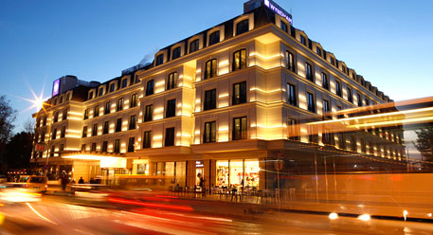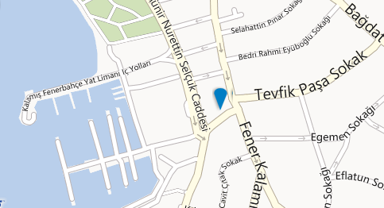
http://www.wyndham.com/hotels/turkey/istanbul/wyndham-istanbul-kalamis-marina/hotel-overview
Wyndham Istanbul Kalamış Marina is located on the Asian coast of Istanbul adjacent to the exclusive Kalamis Marina, with shopping, attractions, recreation and dining nearby.
For booking, you can directly contact Mr. Arda Başarır at arda.basarir@wyndhamkalamis.com or +90-216-400-0000. Please state that you are a conference participant to get the special rate. The check-in and registration on April 10th, will be available after 2 p.m.
During the conference, lunch and 2 coffee breaks/day will be served by the organization. On April 11, a Gala Dinner will be organized at one of the glamorous sites of Istanbul. Details will be sent after the registration process is completed.

FLIGHTS
Turkish Airlines, flying to 201 destinations in 87 countries as of 2012, would probably offer you a direct flight to Istanbul. (www.thy.com)
AIRPORT TRANSPORTATION TO AND FROM THE HOTEL
From/To Istanbul Sabiha Gökçen Airport (Asian Side)
Public Transportation + Taxi. Havataş buses run from Sabiha Gökçen Airport to Kadıköy Port (last stop) every 30 minutes, from 04:00 am to 01:00 am. (Distance 35 km, duration app. 60 minutes depending on traffic , Ticket price 8 TL). From Kadıköy Port to Wyndham Hotel at Kalamış, the easiest and quickest way is by taxi. (Distance 3 km, duration app. 10 mins, cost app. 10 TL)
On the way back from Kadıköy Port to Sabiha Gökçen Airport Havataş buses run every 30 mins, from 04:15 – 00:45 http://www.havatas.com/en/coach.aspx?i=3
Taxi. Taxis are available in front of the arrival hall. Distance: 35 km., Duration: 60 minutes, Cost: 70-80 TL depending on the traffic.
From/To Istanbul Atatürk Airport (European Side)
Public Transportation + Taxi. Havataş buses run from İstanbul Atatürk Airport to Taksim every 30 minutes, from 04:00 am to 01:00 am, mutually. (Distance 30 km, duration 40 minutes depending on traffic , Ticket price 10 TL). From Taksim to Wyndham Hotel at Kalamış, the easiest and quickest way is by taxi. (Distance 16 km, duration app. 30 mins, cost 30-35 TL) http://www.havatas.com.tr/en/coach.aspx?i=1
Taxi. Taxis are available in front of the arrival hall. Distance: 40 km., Duration: 60 minutes, Cost: 80-90 TL depending on the traffic, incl. bridge)

TIME ZONE
GMT +2 (+3 in summertime)

WEATHER
It is delightful to visit İstanbul in April, when days are temperate and evenings mild. Occasionally, poyraz, a chill Balkan wind, and lodos, hot, humid gusts from the south, can result in a 'four seasons in a single day' effect. Avarage temperature is between 7°C - 16°C, but we strongly recommend that you check the weather forecast for Istanbul shortly prior to your arrival.

CURRENCY
New Turkish Lira (TL) is the official currency of Turkey. This replaces the old Turkish Lira (with multiple zeros), which went out of circulation in December 2005. TL has an exchange rate of approx. 2.35 TL per 1 Euro. Currency exchange points in Turkey do not charge commission but rates can vary slightly. Bank notes come in denominations of 5, 10, 20, 50, and 100TL, while coins, called the Kurus (kr), come in 1, 5, 10, 25, and 50 kurus pieces. There is also a 1 TL coin.
ATM'S, CREDIT CARDS, EXCHANGE BUREAUS
ATMs of different local banks are usually clustered together around centres, including at the Arrivals terminal at Atatürk Airport, Sabiha Gökçen Airport and Bağdat Caddesi (closest shopping district to the conference venue). The most widespread local banks in Istanbul include: Garanti Bankasi, Akbank, Is Bankasi and Yapi Kredi Bankasi. Most Turkish bank machines are on the Cirrus and PLUS Networks. If you are planning to use your cards in Turkey and Istanbul, check the back of your card to make sure that your credit card is on these networks.
Credit cards are also widely used and accepted in Turkey and Istanbul.
If you prefer to carry your own currency with you to Istanbul, you can also exchange it at Turkish currency exchange offices called ‘Döviz Bürosu’. There are exchange offices in the airport Arrivals terminal, Taksim and Bağdat Caddesi. Restaurants and hotels in highly touristic areas like Sultanahmet and Taksim also accept US Dollars or Euros but rates are often not competitive.
Information about Istanbul, its history, culture and tourism can be found at
http://english.istanbul.gov.tr
For things to do near Wyndham Kalamış Marina
http://www.wyndham.com/hotels/turkey/istanbul/wyndham-istanbul-kalamis-marina/information-things-to-do?partner_id=&hotel_id=44971&campaign_code=&propId=WY44971&checkout_date&brand_id=WY&children=0&corporate_id&useWRPoints=false&ratePlan&teens=0&affiliate_id=&iata=&rate_code&adults=1&checkin_date&rooms=1
Activities for those looking for an extended stay can be found at
http://www.timeoutistanbul.com/en

Looking forward to see you in Istanbul!

