 | 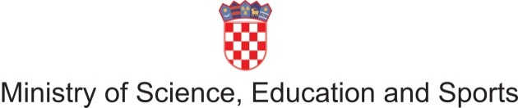  Croatian Qualifications Framework

International Conference on
Referencing and Self-certification of the CROQF to the EQF and to the QF-EHEA

27 October 2011
Campus of the University of Split, Split

Working languages of the Conference are English and Croatian (translation provided)

Draft Agenda
08:30 | Registration of participants
09:00 | Welcome and introduction | Staša Skenžić  Director of Directorate for International Cooperation and European Integrations, Ministry of Science, Education and Sports, Republic of Croatia
09:20 | Qualifications Framework of the European Higher Education Area | Sjur Bergan  Head of Department of Higher Education and History Teaching, Directorate of Education and Languages, Council of Europe
09:40 | Implementation of the European Qualifications Framework | Eduard Staudecker  Federal Ministry of Education, Art and Culture, Austria
10:00 | Quality Assurance in the referencing and self- certification process | Ewa Chmielecka  National coordinator of the Polish NQF and Prime Minister's Advisor on NQF
10:20 | National qualifications frameworks worldwide | Michael Graham
10:40 | Coffee break | Specialist in Qualifications Systems, European Training Foundation
11:10 | South East European Network | Meta Dobnikar  Head of Higher Education Division, Ministry of Higher Education, Science and Technology, Republic of Slovenia
11:30 | Croatian Qualifications Framework: Referencing of the CROQF to the EQF and the QF-EHEA | Mile Dželalija  Head of the Expert Team for the support to the Committee for the Implementation of CROQF
12:30 | Lunch break
13:30 | CROQF institutional and legislative framework:  Stakeholders  Implementation  Further development | AnaTecilazić-Goršić  Head of Department for European Integrations at Directorate for International Cooperation and European Integrations, Ministry of Science, Education and Sports, Republic of Croatia
14:00 | Panel discussions  - Mobility and recognition of foreign qualifications  - Lifelong Learning and Recognition of Prior Learning  - Labour Market and Qualifications Frameworks
  Croatian Qualifications Framework
16:45  17:00 | Coffee Break  Conclusions |  | Moderators of the Panel discussions (TBC)
17:30 | End of Conference

