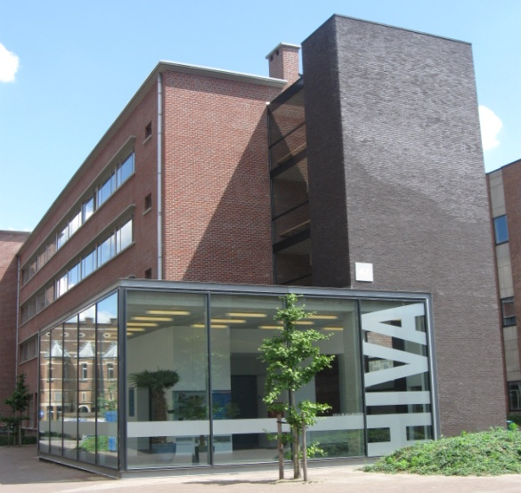
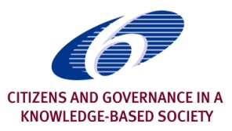
European Commission
Do three sides always make a triangle?
Policy, institutions and learners
in lifelong formal learning

LLL2010 final international conference
Leuven – Belgium, 7-8 February 2011
Objective
This conference presents the final outputs of the LLL2010 research project, an Integrated Project from the EC’s 6th Framework Programme about the role of formal adult education in fostering lifelong learning, with a particular emphasis on disadvantaged groups see http://LLL2010.tlu.ee/). The project is coordinated by prof. Ellu Saar from IISS (Tallinn Pedagogical University).
Target audience
European Commission and related EU institutions, national policy makers, public service officers, social partners, civil society organisations, adult education institutions, representatives of adult learners, researchers, …
Organised by
the Research Institute for Work and Society (HIVA) of the Catholic University of Leuven, Belgium
In association with
the LLL2010 consortium, coordinated by IISS, Tallin – Estonia
With core funding from
the 6th Framework Programme of the European Community

Visit the conference websites (http://LLL2010.tlu.ee/ and http://www.hiva.be/en/)
for the latest news on the conference and
registration of your participation!

Draft Programme
Draft Programme

Monday, 7th February 2011
Chairman of the morning session:
Ides Nicaise (HIVA, KU Leuven)
08:30 Registration
Session I
Opening Session
09:00 Welcome address

09:15 The LLL2010 Project
Ellu Saar (IISS, Tallin)
09:45 Comment
Berhard Chabera (DG EAC)

10:00 Plenary debate

10:30 Coffee break
Session II
The shifting rationale for lifelong learning policies
11:00 Patterns of policy in LLL in the multiple contexts of thirteen European countries
John Holford (Univ. Nottingham) & Elisabet Weedon (Univ. Edinburgh)
11:30 National cases

11:45 Discussant: Jacky Brine (UWE Bristol - tbc)

12:00 Plenary debate

12:30 Lunch
Chairman of the afternoon session:
Michael Teutsch (DG EAC)
Session III
Participation of adults in formal learning: national patterns and social profiles
14:00 Adults’ participation in formal learning: lessons from the Adult Education Survey
Peter Robert (Tarki, Budapest)
14:30 Adults’ participation in lifelong learning: lessons from the Labour Force Survey
Stephanie Rammel & Paul Ringler (3SL, Vienna)
15:00 Discussant: Sadiq-Kwesi Boateng (Eurostat)

15:15 Plenary debate

15:45 Coffee
Session IV
The adult learners: what drives them, and what hinders them ?
16:15 The Learners’ voices: diversities of motivation, expectation and satisfaction
Ides Nicaise & Ellen Boeren (HIVA - KU Leuven)
16:45 Overcoming obstacles to adult learning
Ellu Saar & Eve-Liis Roosma (IISS, Tallin)
17:15 Discussant: Kjell Rubenson (UBC, Vancouver)

17:30 Plenary debate

18:00 End of day 1

19:00 Social programme
(advance registration required)
20:30 Conference dinner
(advance registration required)

Tuesday, 8th February 2011
Chairman of the morning session:
representative from DG RTD (tbc)
Session V
Is there a place for formal education in the training cultures of enterprises?
09:00 Patterns of support for formal educaton in enterprises
Jorg Markowitsch & Gunter Hefler (Danube Univ. Krems)
09:30 National cases

09:45 Discussant: Margarethe Rudzki (Eurochambres -tbc)

10:00 Plenary debate

10:30 Coffee

Session VI
Does the educational institution matter?
11:00 The role of educational institutions for promotion of access of adults to formal education
Paul Downes
11:30 National cases

11:45 Discussant: Philip O’Connell (ESRI Dublin - tbc)

12:00 Plenary debate

12:30 Lunch

Chair of the afternoon session:
Sheila Riddell (Univ. of Edinburgh)
Session VII
Lifelong Learning for all?
(Based on SP 3 and SP 5)
14:00 Policies and practices towards underrepresented and socially excluded groups
Paul Downes & Catherine Maunsell
14:30 National cases

14:45 Discussant: Gina Ebner (EAEA)

15:00 Plenary debate

15:30 Coffee

Session VIII
Closing session
16:00 Round table: European policy on lifelong learning: how to balance equity with efficiency?
Margarida Gameiro (DG EAC – tbc)
Gina Ebner (EAEA)
Vida Spolar Mohorcic (Slovenian Inst. For Adult Education)
Margarethe Rudzki (Eurochambres -tbc)
Jeff Bridgford (ETUI – tbc)

Chair: John Holford
17:30 Closing the conference

Organisation and contact
Ides Nicaise
Email ides.nicaise@hiva.kuleuven.be
Ellen Boeren
Email ellen.boeren@hiva.kuleuven.be

Information and registration
x +32 16 32 33 44http://www.hiva.be

Practical information
Practical information
Date: Monday and Tuesday 7 and 8 February 2011
Conference venue: HIVA – Auditorium Max Weber
Parkstraat 71
BE-3000 Leuven

Conference language: The official conference language is English.

Conference fee: EUR 150 (external participants) / EUR 100 (members of the LLL2010 research consortium)
The conference fee covers the costs of organisation, participation in all sessions, documentation files, lunches and refreshments during break periods and participation to the social programme (advance registration required). The conference dinner is not included.
Social programme: Guided tour and reception in the Leuven Townhall
Free of charge - advance registration required
Conference dinner: EUR 50 - advance registration required

Registration: Please note that the number of participants is limited.
Registration before 20th January 2011 is necessary and is only valid after payment has been received.
Upon reception of your registration form, the conference secretariat will send each participant an invoice for the registration fee. This invoice is at the same time a confirmation of your registration.

Cancellation: The conference secretariat must be notified in writing of cancellation of registration. No refunds provided if cancellations are made after February 1st, 2011.

More information: http://LLL2010.tlu.ee/ and http://www.hiva.be/en/

Project coordinator: Institute for International and Social Studies, Tallinn University (Iiss), Estonia

Partners of the Research Institute for Work and Society - Catholic University of Leuven (HIVA-K.U.Leuven), Belgium

research project: School of Education, University of Nottingham, United Kingdom Moray House School for Education - University of Edinburgh, United Kingdom Educational Disadvantage Centre, and Centre for Human Development at St. Patrick’s College - Dublin City University (EDC/CSHD), Ireland FAFO Institute for Labour and Social Research (FAFO), OSLO – Norway Slovenian Institute for Adult Education (SIAE), Ljubljana – Slovenia Tárki Social Research Institute (TARKI), Budapest – Hungary Mykolas Romeris University (MRU), VILNIUS – Lithuania Institute of Sociology (IS), Sofia – Bulgaria Department of Sociology, Department of Retraining and Improvement of Professional Skills for Sociology and Social Work - St. Petersburg State University (SPSU), Russian Federation The National Training Fund (NTF), Prague - Czech Republic Institute for Social Research (STI), Vilnius – Lithuania Danube University Krems - University for Continuing Education (DUK), Austria

