Registration form  LLL2010 Final conference: Do three sides always make a triangle? Policy, institutions and learners in lifelong formal learning Leuven / Belgium, 7-8 February 2011  Please return this form to: Mrs. Kathleen Postelmans  (before 20 January 2011) Research Institute for Work and Society – K.U.Leuven  Parkstraat 47 – Box 5300, B-3000 Leuven (Belgium)  Fax: +32 16 32 33 44  Email: kathleen.postelmans@hiva.kuleuven.be  Please duplicate this form for every participant  The form should be completed by either typing or writing in capitals |  |  |  | 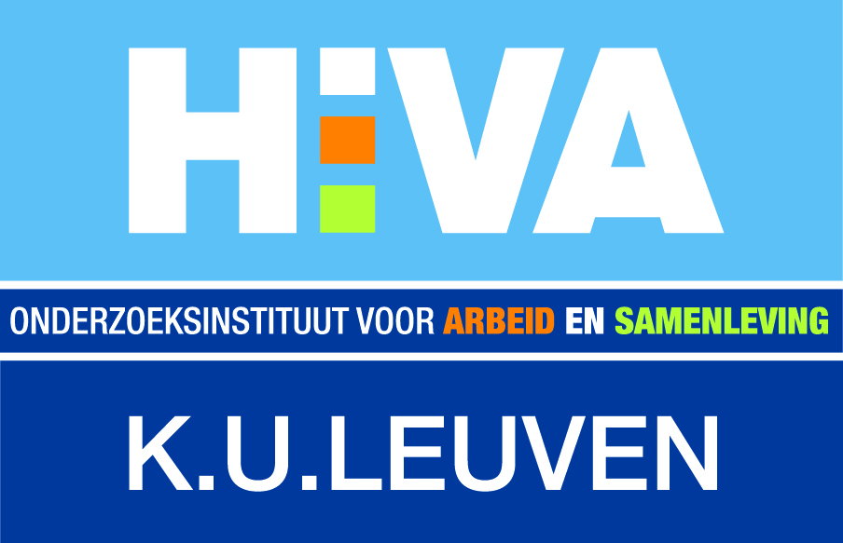
Participant
Prof./Dr./Ms./Mr. |  | First + last name*
Job title*
Organisation*
(+ Department)
Address*
 |  | Town*
Post / ZIP code* |  | Country*
Phone* |  | Fax
Email* |  |  |  | Sexe | W / M
VAT number*
I will attend the conference on: 7 February 8 February (150 euro including lunches)
the lunch on: 7 February 8 February
the social programme on 7 February (for free - advance registration required)
the conference dinner on 7 February (+50 euro - advance registration required)
Please reserve a parking slot on: 7 February 8 February * essential information
Invoice information
Please pay after receipt of an invoice.
The invoice will be send to (please complete if this information is different from the registered person):
Prof./Dr./Ms./Mr. |  | First + last name
Organisation
(+ Department)
Address
 |  | Town
Post / ZIP code |  | Country
Order number | (if your organisation is obliged to work with order forms)
Special requirements Do you have special requirements? Please let us know.
Access
Dietary
General terms and conditions of sale
I hereby acknowledge that I have read and understood the terms and conditions as provided in the K.U.Leuven Continuing Education – General terms and conditions of sale, available at https://www.avnet.kuleuven.be/lll/permanentevorming/verkoop/Verkoopsvoorwaarden_eng and I agree to all of the terms.
For further information, you can contact the conference secretariat.
Mrs. Kathleen Postelmans, Research Institute for Work and Society – K.U.Leuven, Parkstraat 47 – box 5300, B-3000 Leuven, Belgium
Phone +32 16 32 31 07 Fax +32 16 32 33 44 Email kathleen.postelmans@hiva.kuleuven.be.

